Melbourne Bridge Club
MCC Kew 397 Barkers Rd Kew 3101

Phone 9817 3936 ABN No: 88 791 813 415
website www.melbournebridge.com.au

Directors: Ian Mansell Sandra Mansell

Newsletter for week ending 14 Feb 2016

North - South East - West
Monday Day Jean Buttner & Elsa Hatfield** Lesley Johnstone & Sally Foster
Night M & G Penwarden=S Moore & C Urdevics Denise Oppy & Merrliyn Beeny
Tuesday Day Michael Bugler & Haddon Storey Lesley Johnstone & Ronda Cross
Night Robin Tuttleby & Sean Tunney Janet Reynolds & Peter Cork**
Wednesday Louise Buckle & John Waldie** Maria King & Elly Papas
Friday Steve Gapper & Richard Gilbert** Rex Fox & Bridgitte Stutte
Saturday Gerda & Eric Thurin

Our first centenarian
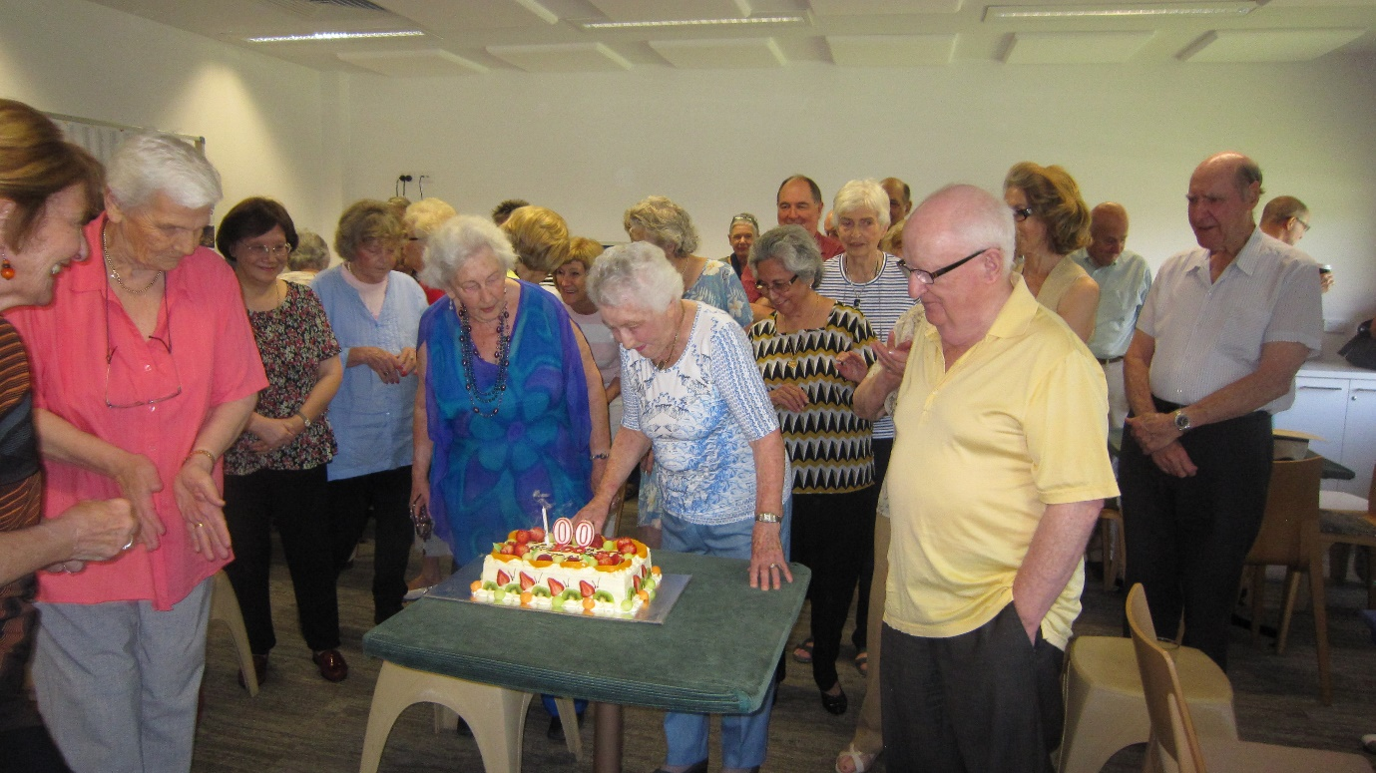
Congratulations and best wishes to Joan Smurthwaite who was born on 14th February 1916 in Wellington NSW. Joan married a banker in 1939 and has four children, 10 grandchildren and two great grandchildren. She started playing bridge at the Melbourne Bridge Club 35 years ago and has successfully competed ever since. As we all know, Joan and her partner Ann Perrott regularly win the North-South competition on Fridays, thereby showing that age is no barrier to playing good bridge

Hand of the week Saturday 13 February board 20 all vul Dealer W
♠ J7542
♥ KJ1092
♦ 108
♣ 9
♠ AKQ10963 ♠ 8
♥ 4 ♥ 863
♦ 5 ♦ Q74
♣ 10876 ♣ AKQ543
♠ -
♥ AQ75
♦ AKJ9632
♣ J2

N E S W
1♠
- 2♣ X 2♠
3♥ - 4♣ 4♠
- - 5♦ -
6♥ =
Some hands are difficult to bid II

West has 9 HCP and a seven card spade suit. What should West open? With the two doubletons I consider the hand too strong to pre-empt and therefore West should open with 1♠. North passes and East bids 2♣.

South doubles and West rebids their spades. North (with long spades) can work out that South has no spades and therefore can confidently bid 3♥.

South wishes to try for slam so therefore asks for aces with 4♣. North interferes with 4♠, and after North and East pass, South shows their second suit by bidding 5♦, which North should “correct” to 6♥ figuring that South’s 4♣ is looking for the A♣ and with a shortage in clubs their hand is therefore worth the 6♥ bid.

The next Red Point events will be Tuesday 1st March at 7.30pm and Saturday 27th February at 1.00 pm. All welcome.

2016 Subscriptions will be due in March. Further details will be advised.

Sandra and Ian

